**DR B.R. AMBEDKAR NATIONAL INSTITUTE OF**

**TECHNOLOGY JALANDHAR**



LAB FILEOFSystem Simulation and ModelingCSX-424

Session: Jan - May 2021

**SUBMITTED TO-**

Dr. Kuldeep Kumar

Assistant Professor

CSE Department

**SUBMITTED BY-**

Ankit Goyal

Roll No.- 17103011

Group - G-1

Branch - CSE

**INDEX**

|  |  |  |  |
| --- | --- | --- | --- |
| **S. No** | **Table of contents** | **Page Numbers** | **Remarks** |
| **1.** | Implement Chi Square Test | 3 |  |
| **2.** | Generate random numbers using (i) mid-square method, (ii) residue method, (iii) arithmetic congruence method | 5 |  |
| **3**. | Implement KS Test | 9 |  |
| **4.** | Implement Monte Carlo test | 14 |  |
| **5.** | Implement Geometric & Poisson Distribution | 16 |  |
| **6.** | Implement program to generate random numbers using: a) Triangular distribution b) Uniform distribution | 19 |  |
| **7.** | Implement a menu driven program to generate random numbers using: a) Nominal distribution b) Exponential distribution | 21 |  |
| 8. | Implement a single server queuing system | 23 |  |
| 9. | Implement Two server(Multi) queuing system | 25 |  |

**Experiment -1**

**Aim:** Implement Chi Square Test.

**Theory:**

One of the primary tasks involved in any supervised Machine Learning venture is to select the best features from the given dataset to obtain the best results. One way to select these features is the Chi-Square Test.

Mathematically, a Chi-Square test is done on two distributions two determine the level of similarity of their respective variances. In its **null hypothesis**, it assumes that the given distributions are independent. This test thus can be used to determine the best features for a given dataset by determining the features on which the output class label is most dependent on. For each feature in the dataset, the value is calculated and then ordered in descending order according to the value. The higher the value, the more dependent the output label is on the feature and higher the importance the feature has on determining the output.

**Code:**

#include <bits/stdc++.h>

using namespace std;

int main()

{

float chi;

int random[20];

int s1,s2,mod,i=2;

cout<<"Enter s1 :";

cin>>s1;

cout<<"Enter s2 : ";

cin>>s2;

cout<<"Enter modulus : ";

cin>>mod;

/// Generating Random numbers

random[0] = (s1+s2)%mod;

random[1] = (s2+random[0])%mod;

for(i=2;i<20;i++)

random[i] = (random[i-1] + random[i-2])%mod;

int ctsize = ceil(mod/10);

int ct[20];

memset(ct,0,sizeof(ct));

cout<<"Enter value of chi-square at alpha(0.5) : ";

cin>>chi;

for(i=0;i<20;i++)

{

if(random[i]%ctsize==0)

random[i] = random[i]-1;

ct[random[i]/ctsize + 1]++;

}

cout<<"The hypothesis value of random numbers generated is : ";

for(i=0;i<ctsize;i++)

cout<<ct[i]<<" ";

cout<<endl;

float chisq = 0;

for(i=0;i<ctsize;i++)

{

chisq += ((ctsize - (float)ct[i])*(ctsize - (float)ct[i]))/ctsize;

}

cout<<"The calculated chi sqaure value : "<<chisq<<"\n";

if(chisq<chi)

cout<<"The hypothesis is true: The numbers are uniformly distributed";

else

cout<<"The hypothesis is rejected.";

}

**Output:**

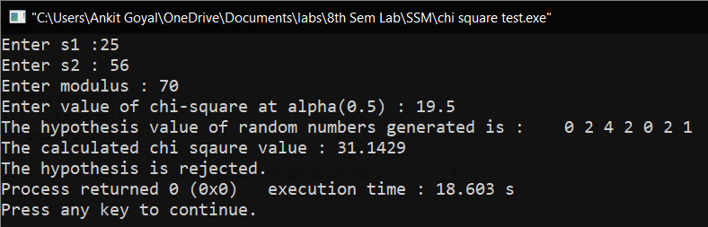

**Experiment -2**

**Aim:** To generate random numbers using:

1. Mid square method
2. Residue method
3. Arithmetic congruence method

**Theory:**

**Mid Square Method** was proposed by Van Neumann. In this method, we have a seed and then the seed is squared and its midterm is fetched as the random number. Consider if we have a seed having N digits we square that number to get a 2N digits number if it doesn’t become 2N digits we add zeros before the number to make it 2N digits.

The most common method of generating the random number sequence is known as **the residue method**. Multiply the previous random number by the constant a, add on another constant c, take the modulus by M, and then keep just the fractional part (remainder) as the next random number.  
  
**Arithmetic Congruential Method** uses 2 seed values to generate random numbers. It is described by formula :   
Rn+1 = (Rn-1 + Rn)mod M

**Code:**

#include<bits/stdc++.h>

using namespace std;

long long a[] = { 1, 10, 100, 1000, 10000, 100000, 1000000, 10000000, 100000000 };

int middleSquareNumber(int numb, int dig)

{

long long int sqn = numb * numb, next_num = 0;

int trim = (dig / 2);

sqn = sqn / a[trim];

for (int i = 0; i < dig; i++)

{

next_num += (sqn % (a[trim])) * (a[i]);

sqn = sqn / 10;

}

return next_num;

}

void midsq()

{

cout<<"Enter the seed value :";

int seed;

cin>>seed;

int dig;

cout<<"Enter the number of digits :";

cin>>dig;

int n;

cout<<"Enter the number of random numbers you want to generate: ";

cin>>n;

cout<<"The random numbers are: ";

cout<<seed<<", ";

int ni=seed;

for(int i=1; i<n; ++i)

{

ni = middleSquareNumber(ni,dig);

cout<<ni<<", ";

}

cout<<"\n";

}

void residue()

{

int a,c,M,r;

cout<<"Enter the value of 'a', 'c' and 'M': ";

cin>>a>>c>>M;

cout<<"Enter the number of random numbers you want :";

int n;

cin>>n;

cout<<"Enter the first random number: ";

cin>>r;

cout<<"The random numbers are: ";

cout<<r<<", ";

int rd=r;

for(int i=1; i<n; ++i)

{

r= (a*rd+ c)%M;

rd=r;

cout<<r<<", ";

}

cout<<"\n";

}

void arithmeticCong()

{

int n,a,b,m;

cout<<"Enter the number of random numbers you want to generate :";

cin>>n;

cout<<"Enter the seed values: ";

cin>>a>>b;

cout<<"Enter the value of M";

cin>>m;

int r;

cout<<"The random numbers generated are :";

for(int i=0; i<n; ++i)

{

r=(a+b)%m;

b=a;

a=r;

cout<<r<<", ";

}

cout<<"\n";

}

int main()

{

int choice;

do{

cout<<"Enter the choice of Algorithm for generating random numbers\n1.Mid square method\n2.Residue Method\n3.Arithmetic Congruential Method\n4.Exit\n";

cin>>choice;

switch(choice)

{

case 1: midsq();

break;

case 2: residue();

break;

case 3: arithmeticCong();

break;

case 4:

break;

default:

cout<<"Wrong choice\n";

break;

}

}while(choice<4);

}

**Output:**

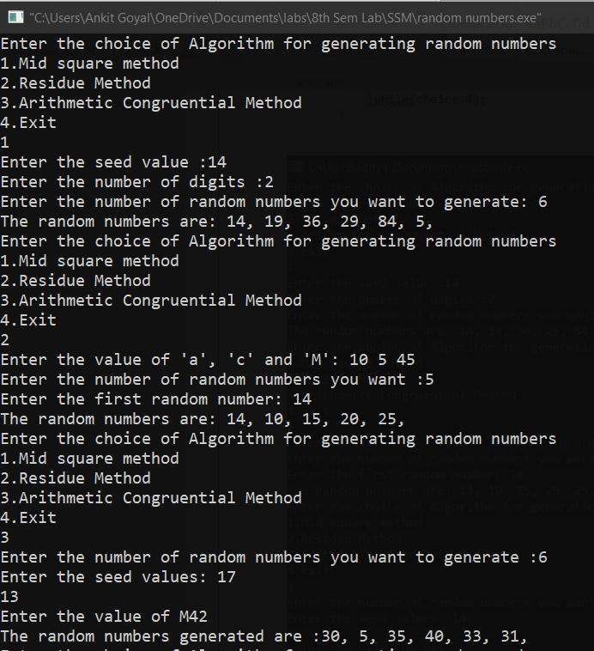

**Experiment -3**

**Aim:** Implement a program to perform Kolmogorov Smirnov (KS) test.

**THEORY:**

Kolmogorov–Smirnov test a very efficient way to determine if two samples are significantly different from each other. It is usually used to check the uniformity of random numbers. Uniformity is one of the most important properties of any random number generator and Kolmogorov–Smirnov test can be used to test it.

The Kolmogorov–Smirnov test may also be used to test whether two underlying one-dimensional probability distributions differ. It is a very efficient way to determine if two samples are significantly different from each other.

The Kolmogorov–Smirnov statistic quantifies a distance between the empirical distribution function of the sample and the cumulative distribution function of the reference distribution, or between the empirical distribution functions of two samples.

To use the test for checking the uniformity of random numbers, we use the CDF (cumulative distribution function) of U[0, 1].

F(x)= x for 0<=x<=1

Empirical CDF, Sn(x)= (number of R1, R2…Rn < x)/N array of random numbers, the random numbers must be in the range of [0, 1].

**PROGRAM:**

#include<bits/stdc++.h>

using namespace std;

class KS

{

private:

float numbers[20];

float D,tabulatedD;

float Dplusmax,Dminusmax;

float Dplus[20],Dminus[20];

float ratio[20],ratiominus[20];

int i,j,n;

public:

void getdata() //to get the random numbers

{

cout<<"How many numbers?:"<<endl;

cin>>n;

cout<<"Enter "<<n<<" numbers"<<endl;

for(i=0;i<n;i++)

{

cout<<"Enter "<<i+1<<" number:"<<endl;

cin>>numbers[i];

}

}

void BubbleSort() // arrange the number in increasing order

{

int i,j;

float temp;

for(i=0;i<n-1;i++)

{

for(j=0;j<n-i-1;j++)

{

if(numbers[j]>numbers[j+1])

{

temp=numbers[j];

numbers[j]=numbers[j+1];

numbers[j+1]=temp;

}

}

}

cout<<"The numbers in ascending order is:"<<endl;

for(i=0;i<n;i++)

{

cout<<setprecision(2)<<numbers[i]<<" ";

}

}

void calculate() // find D+, D-

{

for(i=0;i<n;i++)

{

int j;

j=i+1;

ratio[i]=(float)j/n;

ratiominus[i]=(float)i/n;

Dplus[i]=ratio[i]-numbers[i];

Dminus[i]=numbers[i]-ratiominus[i];

}

}

void display() // display the tabulated format and find D

{

cout<<endl;

cout<<endl;

cout<<setw(10)<<"i";

for(i=1;i<=n;i++)

{

cout<<setw(10)<<i;

}

cout<<endl;

cout<<setw(10)<<"R(i)";

for(i=0;i<n;i++)

{

cout<<setw(10)<<numbers[i];

}

cout<<endl;

cout<<setw(10)<<"i/n";

for(i=0;i<n;i++)

{

cout<<setw(10)<<setprecision(2)<<ratio[i];

}

cout<<endl;

cout<<setw(10)<<"D+";

for(i=0;i<n;i++)

{

cout<<setw(10)<<setprecision(2)<<Dplus[i];

}

cout<<endl;

cout<<setw(10)<<"D-";

for(i=0;i<n;i++)

{

cout<<setw(10)<<setprecision(2)<<Dminus[i];

}

cout<<endl;

Dplusmax=Dplus[0];

Dminusmax=Dminus[0];

for(i=1;i<n;i++)

{

if(Dplus[i]>Dplusmax)

{

Dplusmax=Dplus[i];

}

if(Dminus[i]>Dminusmax)

{

Dminusmax=Dminus[i];

}

}

cout<<"D+ max: "<<Dplusmax<<endl;

cout<<"D- max: "<<Dminusmax<<endl;

cout<<"D =max("<<Dplusmax<<", "<<Dminusmax<<") =";

if(Dplusmax>Dminusmax)

{

D=Dplusmax;

}

else

{

D=Dminusmax;

}

cout<<D;

cout<<endl;

}

void conclusion() // asking tabulated D and comparing it with D(calculated)

{

cout<<"Enter the tabulated value:"<<endl;

cin>>tabulatedD;

if(D<tabulatedD)

{

cout<<"The test is accepted."<<endl;

}

else

{

cout<<"The test is rejected."<<endl;

}

}

};

int main() //main function

{

KS ks1; //object of KS class

ks1.getdata(); //function calls

ks1.BubbleSort();

ks1.calculate();

ks1.display();

ks1.conclusion();

return(0);

}

**OUTPUT:**

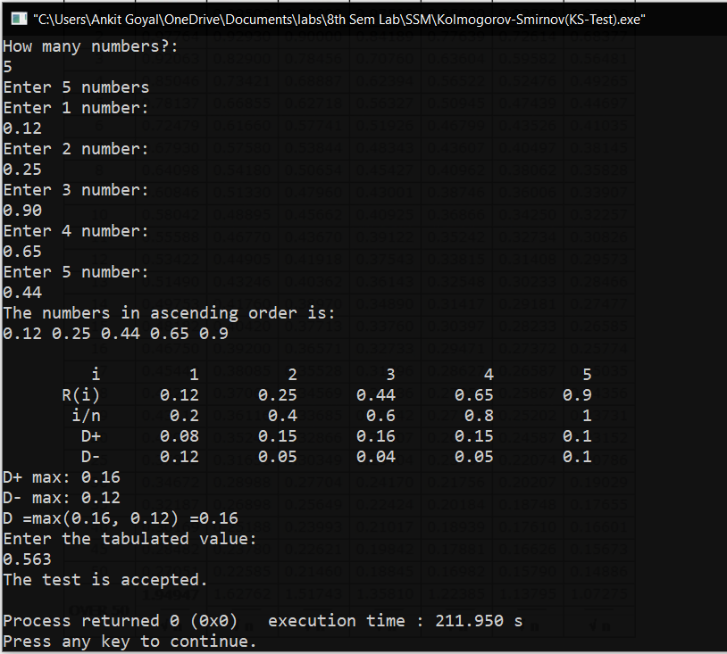

**Experiment -4**

**Aim:** To implement a Monte Carlo Simulation.

**Theory:**

Monte Carlo simulation is a computerized mathematical technique that allows people to account for risk in quantitative analysis and decision making. The technique is used by  
professionals in such widely disparate fields as finance, project management, energy,  
manufacturing, engineering, research and development, insurance, oil & gas,  
transportation, and the environment. Monte Carlo simulation furnishes the decision-maker  
with a range of possible outcomes and the probabilities they will occur for any choice of  
action. It shows the extreme possibilities the outcomes of going for broke and for the most  
conservative decision along with all possible consequences for middle-of-the-road  
decisions.

**Example:**

Dr. Ravi, a dentist schedules all his patients for 30 minute appointments. Some  
of the patients take more or less than 30 minutes depending on the type of dental work to  
be done. The following table shows the summary of the various categories of work, their  
probabilities and the time actually needed to complete the work.

|  |  |  |
| --- | --- | --- |
| Category | Time Required(minutes) | No. of Patients |
| Filling | 45 | 40 |
| Crown | 60 | 15 |
| Cleaning | 15 | 15 |
| Extraction | 45 | 10 |
| Check-up | 15 | 20 |

Simulate the dentist’s clinic for four hours and determine the average waiting time for the  
patients as well as the idleness of the doctor. Assume that all the patients show up at the  
clinic exactly at their scheduled arrival time, starting at 8.00 am. Use the following random  
numbers for handling the above problem: 40, 82, 11, 34, 25, 66, 17, 79

**Code:**

#include<bits/stdc++.h>

using namespace std;

int main()

{

unordered_map<string,int> serviceTime={{"filling",45},{"crown",60},{"cleaning",15},{"extraction",45},{"check-up",15}};

vector<int> numbers{40,82,11,34,25,66,17,79};

int curTime=0,maxTime=0;

int idle=0;

int wait=0;

for(int i=0;i<8;i++)

{

if(curTime>maxTime)

{

idle+=(curTime-maxTime);

maxTime=curTime;

}

wait+=(maxTime-curTime);

curTime+=30;

string type="";

if(numbers[i]<40)

type="filling";

else if(numbers[i]<55)

type="crown";

else if(numbers[i]<70)

type="cleaning";

else if(numbers[i]<80)

type="extraction";

else

type="check-up";

maxTime+=serviceTime[type];

}

cout<<"Dentist remains idle for "<<idle<<" minutes\n";

cout<<"Average waiting time for patients is :"<<((float)wait/8.0)<<" minutes\n";

return 0;

}

**Output:**

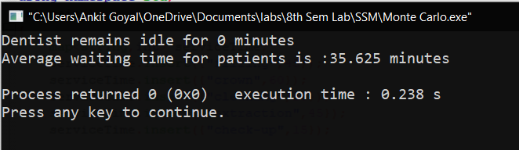

**Experiment -5**

**AIM:** Implement a program to perform Geometric and Poisson Distribution.

**THEORY:**

**1. GEOMETRIC DISTRIBUTION:**The geometric distribution represents the number of failures before you get a success in a series of Bernoulli trials. This discrete probability distribution is represented by the probability density function:

f(x) = (1 - p)x - 1p

For example, you ask people outside a polling station who they voted for until you find someone that voted for the independent candidate in a local election. The geometric distribution would represent the number of people who you had to poll before you found someone who voted independent. You would need to get a certain number of failures before you got your first success.

**Program:**

#include <iostream>

#include <random>

using namespace std;

int main(void) {

const int nrolls = 10000; // number of experiments

const int nstars = 100; // maximum number of stars to distribute

default_random_engine generator;

geometric_distribution <int> distribution (0.3);

int p[10] = {};

for (int i=0; i < nrolls; ++i) {

int number = distribution (generator);

if (number < 10) {

++p[number];

}

}

cout << "geometric_distribution (0.3):" << endl;

for (int i = 0; i < 10; ++i)

cout << i << ": " << string(p[i] * nstars / nrolls, '*') << endl;

return 0;

}

**Output:**

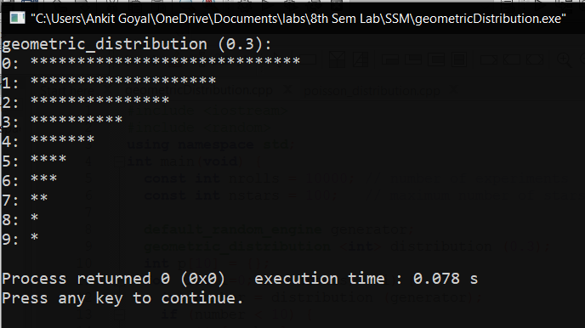

2. POISSON DISTRIBUTION**:**A Poisson distribution is a tool that helps to predict the probability of certain events from happening when you know how often the event has occurred. It gives us the probability of a given number of events happening in a fixed interval of time.  
The Poisson Distribution pmf is:

P(x; μ) = (e-μ * μx) / x!

Where:  
● The symbol “!” is a factorial.  
● μ (the expected number of occurrences) is sometimes written as λ. Sometimes called the event rate or rate parameter.

**Program:**

#include <iostream>

#include <random>

using namespace std;

int main()

{

const int nrolls = 10000; // number of experiments

const int nstars = 100; // maximum number of stars to distribute

default_random_engine generator;

poisson_distribution<int> distribution(4.1);

int p[10]={};

for (int i=0; i<nrolls; ++i) {

int number = distribution(generator);

if (number<10) ++p[number];

}

cout << "poisson_distribution (mean=4.1):" << endl;

for (int i=0; i<10; ++i)

cout << i << ": " << string(p[i]*nstars/nrolls,'*') << endl;

return 0;

}

**Output:**

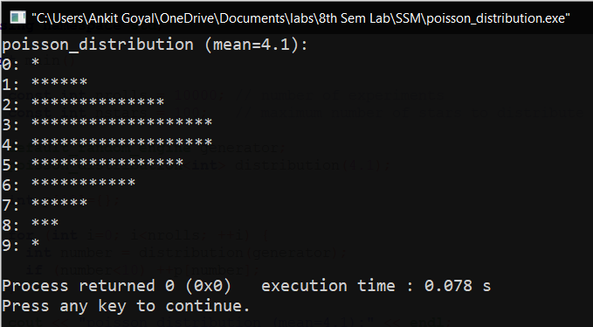

**Experiment -6**

**Aim:** Implement a menu driven program to generate random numbers using: a) Triangular distribution b) Uniform distribution.

**Program:**

#include <random>

#include <iostream>

#include <iomanip>

#include <array>

#include <map>

using namespace std;

piecewise_linear_distribution<double> triangular_distribution(double min, double peak, double max)

{

array<double, 3> i{min, peak, max};

array<double, 3> w{0, 1, 0};

return piecewise_linear_distribution<double>{i.begin(), i.end(), w.begin()};

}

int main() {

int choice;

cout<<"Enter \n1. For Triangular distribution and \n2. For uniform distribution\n";

cin>>choice;

if(choice&1){

random_device rd;

mt19937 gen(rd());

auto dist = triangular_distribution(0, 7, 10);

map<int, int> hist;

for (int i = 0; i < 4000; ++i) {

double num = dist(gen);

++hist[num];

}

cout<<"Following are the random numbers generated : ";

for(auto p : hist) {

cout << p.second/10<< " ";

}

cout<<"\n enter 1 for the graph : \n";

int x;

cin>>x;

if(x&1){

for(auto p : hist) {

cout << setw(2) << setfill('0') << p.first << ' '

<< string(p.second/10,'*') << '\n';

}

}

}

else{

const int nrolls=500;

const int nstars=95;

const int nintervals=10;

default_random_engine generator;

uniform_real_distribution<double> distribution(0.0,1.0);

int p[nintervals]={};

cout<<"Random number generated : ";

for (int i=0; i<nrolls; ++i) {

double number = distribution(generator);

++p[int(nintervals*number)];

cout<<number<<" ";

}

cout<<endl;

cout << "uniform_real_distribution (0.0,1.0):" << endl;

cout << fixed; cout.precision(1);

for (int i=0; i<nintervals; ++i) {

cout << float(i)/nintervals << "-" << float(i+1)/nintervals << ": ";

cout << string(p[i]*nstars/nrolls,'*') << endl;

}

}

}

**Output:**

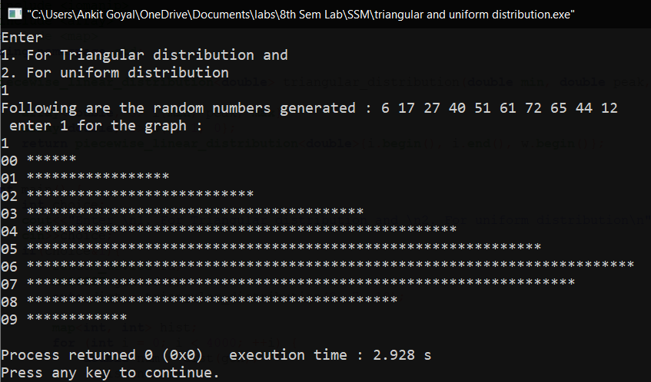

**Experiment -7**

**Aim:** Implement a menu driven program to generate random numbers using: a) Nominal distribution b) Exponential distribution.

**Program:**

#include <bits/stdc++.h>

using namespace std;

void normal()

{

int i, j, m, nn;

float t, sum, x, mue, sigma;

cout << "Enter the value of mue - ";

cin >> mue;

cout << "Enter the value of sigma - ";

cin >> sigma;

cout << "Number of random variables needed - ";

cin >> nn;

for (m = 1; m <= nn; m++)

{

sum = 0;

for (i = 1; i <= 12; i++)

{

x = float(rand()) / float(RAND_MAX);

sum = sum + x;

}

t = mue + sigma * (sum - 6.);

cout << t << " ";

}

}

void expo()

{

int i, j, k, m, nn;

double lambda;

cout << " Enter the value of Lambda ";

cin >> lambda;

cout << "Number of random variables needed - ";

cin >> nn;

for (m = 1; m <= nn; m++)

{

double u = float(rand()) / float(RAND_MAX);

double x = log(1 - u) / (-lambda);

cout << x << " ";

}

}

int main()

{

int c;

while (true)

{

cout << "Press 1 for Normal Distribution " << endl;

cout << "Press 2 for Exponential Distribution " << endl;

cin >> c;

if (c == 1)

normal();

else

expo();

cout << endl;

}

return 0;

}

**Output:**

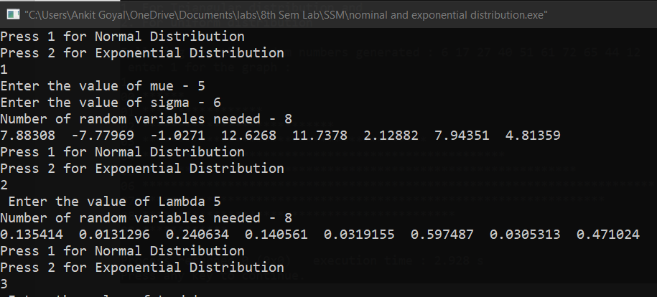

**Experiment -8**

**Aim:** Implement a Single Server Queuing System.

**Code:**

#include<iostream>

#include<iomanip>

#include<cmath>

using namespace std;

double getRandom() {

return (double(rand())/RAND_MAX);

}

class ExponentialDistribution {

double mu;

public:

ExponentialDistribution(double m) {mu=m;}

double generateRandomVariate() {

return (-1/mu)*log(getRandom());

}

};

int main() {

double meanArrival, meanService, nextArrivalTime=0, totalIdleTime=0, idleTime, totalWaitTime=0, waitTime, nextDepartureTime=0, nextServiceBeginTime, service, totalMinutes;

int requestsServed=0;

cout<<"Enter Mean Arrival Rate (per hour): "; cin>>meanArrival;

cout<<"Enter Mean Service Rate (per hour): "; cin>>meanService;

cout<<"Enter Total Simulation Hours: "; cin>>totalMinutes;

totalMinutes=totalMinutes*60;

ExponentialDistribution interArrivalTime(meanArrival/60), serviceTime(meanService/60);

cout<<"R.No.\tArrival_Time\tService_Begin\tService_Time\tDeparture\tWait_Time\tIdle_Time"<<endl;

while(nextDepartureTime<=totalMinutes)

{

nextArrivalTime+=interArrivalTime.generateRandomVariate();

if(nextArrivalTime<=nextDepartureTime)

{

nextServiceBeginTime=nextDepartureTime;

waitTime=nextDepartureTime-nextArrivalTime;

totalWaitTime+=waitTime;

idleTime=0;

}

else

{

nextServiceBeginTime=nextArrivalTime;

idleTime=nextArrivalTime-nextDepartureTime;

totalIdleTime+=idleTime;

waitTime=0;

}

service=serviceTime.generateRandomVariate();

nextDepartureTime=nextServiceBeginTime+service;

++requestsServed;

cout<<setprecision(5)<<requestsServed<<"\t"<<nextArrivalTime<<"\t\t"<<nextServiceBeginTime<<"\t\t"<<service<<"\t\t"<<nextDepartureTime<<"\t\t"<<waitTime<<"\t\t"<<idleTime<<endl;

}

cout<<"Average Wait Time: "<<totalWaitTime/requestsServed<<endl;

cout<<"Idle Time Percentage: "<<totalIdleTime/totalMinutes*100<<endl;

cout<<"Capacity Utilization: "<<(nextArrivalTime-totalIdleTime)/nextArrivalTime*100<<endl;

return 0;

}

**output:**

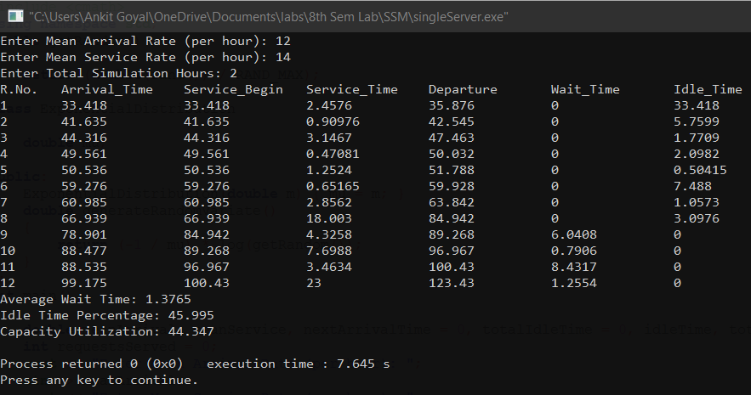

**Experiment -9**

**Aim:** Implement Two server(multi) queuing system.

**Theory:**

The system consists of multiple servers and a common queue for all items. When any item requests for the server, it is allocated if at-least one server is available. Else the queue begins to start until the server is free. In this system, we assume that all servers are identical, i.e. there is no difference which server is chosen for which item. There is an exception of utilization.

Multi server queue has two or more service facilities in parallel providing identical service. All the. customers in the waiting line can be served by more than one station. The arrival time and the service time. follow poisson and exponential distribution.

**Program:**

#include<bits/stdc++.h>

using namespace std;

constexpr int FLOAT_MIN = 0;

constexpr int FLOAT_MAX = 1;

int main()

{

std::random_device rd;

std::default_random_engine eng(rd());

std::uniform_real_distribution<float> distr(FLOAT_MIN, FLOAT_MAX);

float r,iat,clock=0,nat,it1,it2,run=150,cit1=0,cit2=0;

float mean, lemda1, lemda2;

cout<<"enter mean time: ";

cin>>mean;

cout<<"service time of server1: ";

cin>>lemda1;

cout<<"service time of server2: ";

cin>>lemda2;

float se1=0,se2=0;

int k,q=0,qmax=3,kont=0,counter;

printf("\n CLOCK IAT NAT SE1 SE2 QUE KONT CIT1 CIT2");

r=distr(eng);

iat=(-mean)*log(1-r);

nat=nat+iat;

se1=lemda1;

counter=1;

printf("\n %6.2f %6.2f %6.2f %6.2f %6.2f %d %d %6.2f %6.2f ",clock,iat,nat,se1,se2,q,kont,cit1,cit2);

while(clock<=run)

{

if(nat<=se1 && nat<=se2)

{

clock=nat;

q=q+1;

r=distr(eng);

iat = (-mean)*log(1-r);

nat=nat+iat;

counter=counter+1;

}

else if (se1<=nat && se1<=se2)

clock=se1;

else

clock=se2;

if(q>qmax)

{

kont=kont+1;

q=q-1;

}

else if(q>=1 && se1<=clock)

{

it1=clock-se1;

cit1=cit1+it1;

se1=clock+lemda1;

q=q-1;

}

else if(q>=1 && se2<=clock)

{

it2=clock-se2;

cit2=cit2+it2;

se2=clock+lemda2;

q=q-1;

}

else if(q==0&& se1<=clock)

{

clock=nat;

it1=clock-se1;

cit1=cit1+it1;

se1=nat+lemda1;

r=distr(eng);

iat=(-mean)*log(1-r);

nat=nat+iat;

counter=counter+1;

}

else if(q==0 && se2<=clock)

{

clock=nat;

it2=clock-se2;

cit2=cit2+it2;

se2=nat+lemda2;

r=distr(eng);

iat=(-mean)*log(1-r);

nat=nat+iat;

counter=counter+1;

}

printf("\n %6.2f %6.2f %6.2f %6.2f %6.2f %d %d %6.2f %6.2f ",clock,iat,nat,se1,se2,q,kont,cit1,cit2);

}

printf("\n clock=%8.2f cit1=%6.2f cit2=%6.2f counter=%d",clock,cit1,cit2,counter);

printf("\n\n Mean arrival time = %5.2f minutes exponentially distributed",mean);

printf("\n Service time : \nServer1=%5.2f minutes\nServer2=%5.2f minutes",lemda1,lemda2);

printf("\nSimulation run(Elapsed time)=%7.2f minutes",clock);

printf("\nNumber of customers arrived=%d",counter);

printf("\nNumber of customers returned without service=%d",kont);

printf("\nIdle time of server1 = %6.2f minutes",cit1);

printf("\nIdle time of server2 = %6.2f minutes\n",cit2);

}

**OUTPUT:**

